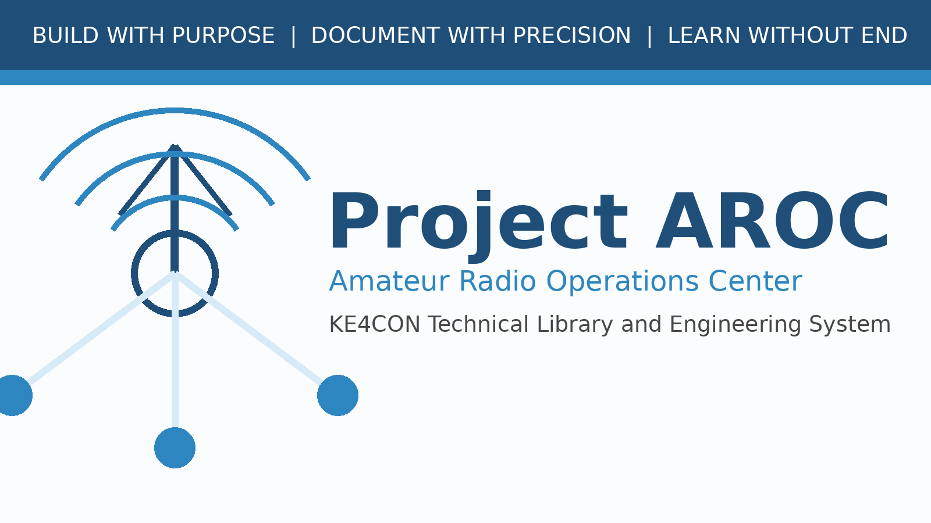

Milestone 0003A Release Notes
Project Publishing Framework

Document Number | AROC-REL-0003A
Revision | 1.0
Status | Draft for Review
Project | Project AROC - KE4CON
Motto | Build with Purpose. Document with Precision. Learn without End.

Document Control
Document Number | AROC-REL-0003A
Title | Milestone 0003A Release Notes
Revision | 1.0
Status | Draft for Review
Owner | James / KE4CON
Technical Author | ChatGPT
Applies To | Project AROC Technical Library and Engineering Documentation

Revision History
Revision | Date | Author | Description | Status
1.0 | 2026-06-30 | ChatGPT | Initial milestone 0003A publication framework draft | Draft

Summary
Milestone 0003A establishes the Project AROC publishing framework. It introduces the official publishing standard, draft visual identity, logo assets, color palette, typography guidance, and reusable document templates.

Included Files
- AROC-STD-0001 Project AROC Publishing Standard Rev0.1
- AROC-BRAND-0001 Project AROC Visual Identity Guide Rev0.1
- Project AROC logo draft PNG and SVG
- Color palette JSON
- Typography guide
- Master document template
- Revision history template

Next Milestone
Milestone 0003B will define engineering standards: document numbering, folder structure, revision control, file naming, figure numbering, table numbering, and diagram standards.

